**Pinning visualizations**

**Introduction**

You're a recently appointed data analyst in Adventure Works. After spending weeks diving deep into various data points, you've crafted a compelling report for a critical department meeting. Using Microsoft Power BI, you’ve transformed raw, complex data into intuitive and insightful visuals that speak volumes about the underlying trends and patterns.

Post-meeting, your inbox is flooded with requests from team members wanting access to your visualizations. They want to track the visualized metrics regularly, study them further, and share them with others. You realize that emailing these visuals back and forth is neither effective nor efficient. There's got to be a better way, right? That's when you remember the pinning visualizations feature in Power BI! This reading aims to assist you in not only understanding this feature and its associated benefits but also how to use it effectively.

**Pinning visualizations**

Pinning a visualization is a powerful feature in Power BI that allows users to add visualizations, reports, or entire report pages from various reports to a dashboard. In simpler terms, pinning a visualization is like bookmarking it for easy access. Power BI dashboards are collections of visuals, reports, and other data that provide a consolidated view of business data. Pinning a visualization, then, is akin to creating a personalized summary page or control center for your data, which can be viewed at a glance. Now, let’s explore some of the benefits of pinning a visualization.

* **Easily access key data points**: One of the key benefits of pinning visualizations is the ability to provide swift access to crucial data points. For example, in Adventure Works, certain metrics like monthly production figures, daily inventory turnover, or quarterly shipping rates are routinely referred to. By pinning these visuals to your dashboard, you are essentially creating a one-stop, easily accessible hub for these key data points. This eliminates the need for you or your colleagues to search through numerous different reports.
* **Facilitate collaboration**: Adventure Works, like any other multinational firm, thrives on teamwork and cross-functional collaboration. The feature of pinning visuals to a shared dashboard can significantly enhance these collaborative efforts. After you've pinned a visual to your dashboard, you can share it with other team members, promoting transparency and unity in the team. Everyone sees the same data, ensuring a single version of the truth across the board.
* **Monitor real-time data**: In the fast-paced world of manufacturing, having real-time data at your fingertips is crucial for prompt decision-making. Your pinned visuals on the Power BI dashboard get updated in real time, reflecting the most recent data. Say, for instance, your manager wants to track the number of bicycle units produced in the plant. The pinned visual will continuously update, enabling her to instantly identify any unexpected fluctuations and react accordingly.
* **Customize view**: At Adventure Works, each team or department has distinct data needs. A production manager might primarily focus on output rates, while a supply chain manager might be more interested in tracking shipment data. The feature of pinning visualizations in Power BI allows each user to create a dashboard that caters specifically to their unique needs. You can pin a wide array of visuals and organize them on your dashboard for a comprehensive overview of your data.

**The pinning process in Power BI**

Now, let's explore the step-by-step process of pinning a visualization in Power BI:

**Step 1: Open the report**

In Power BI service, open the report that contains the visualizations you'd like to pin. In the Adventure Works scenario, this could be a sales report that displays a wide range of data. Each visualization within this report represents a unique data perspective, providing insights that can help drive strategic decision-making.

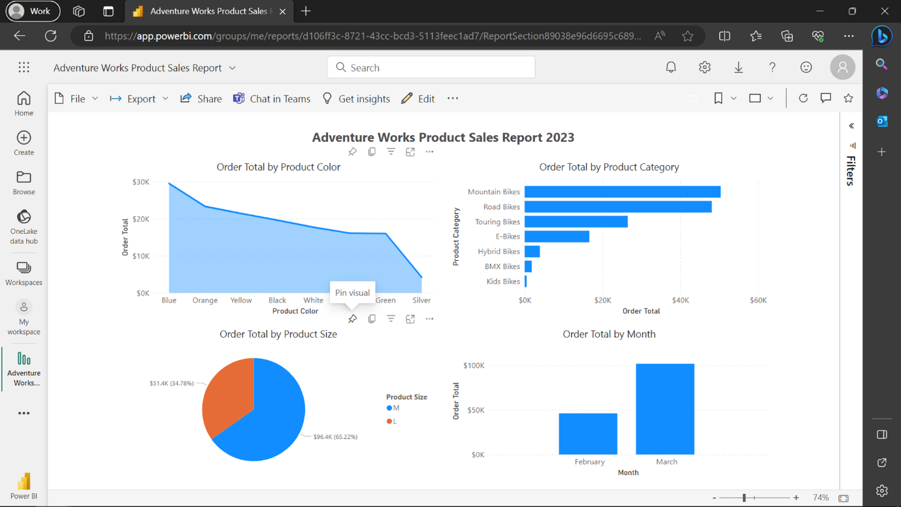

**Step 2: Select visualization**

With your report open, it's time to select the specific visualization you wish to pin. Start by hovering your cursor over the desired visual. As you do this, you'll notice a series of icons appearing at the top right corner of the visual. These icons represent different actions you can perform on the visual. Among them, look for the push pin icon—this is the **Pin visual** button—your ticket to pinning this valuable piece of information onto your dashboard.

Note: The **Pin to dashboard** option is only available in Power BI Service.

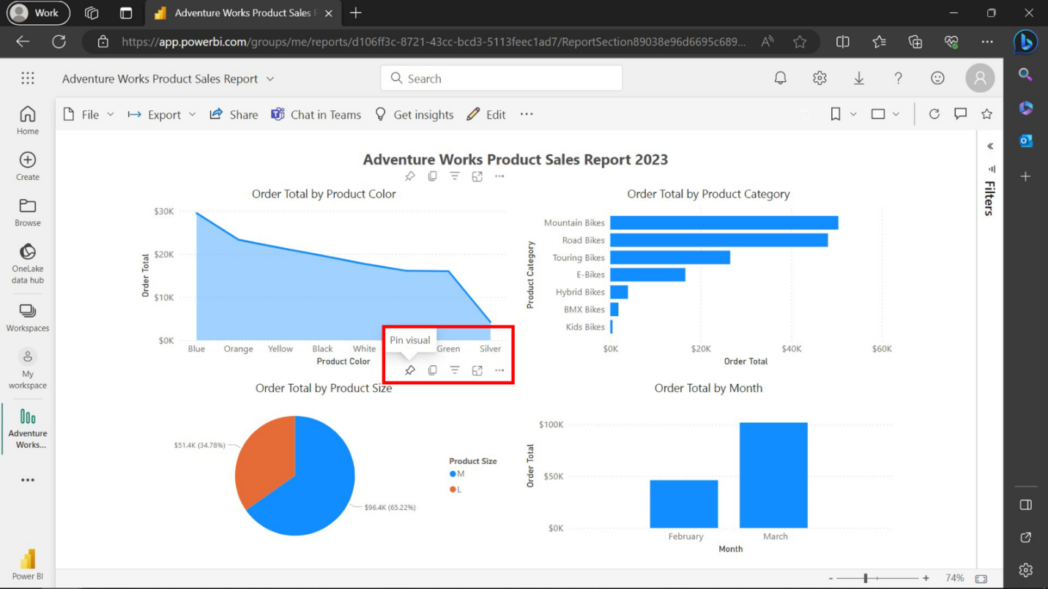

**Step 3: Pin the visual**

Select the **Pin visual** button. A window titled **Pin to dashboard** will open. You're presented with two options here.

1. If you want to pin the visual to an existing dashboard, select it from the dropdown list.

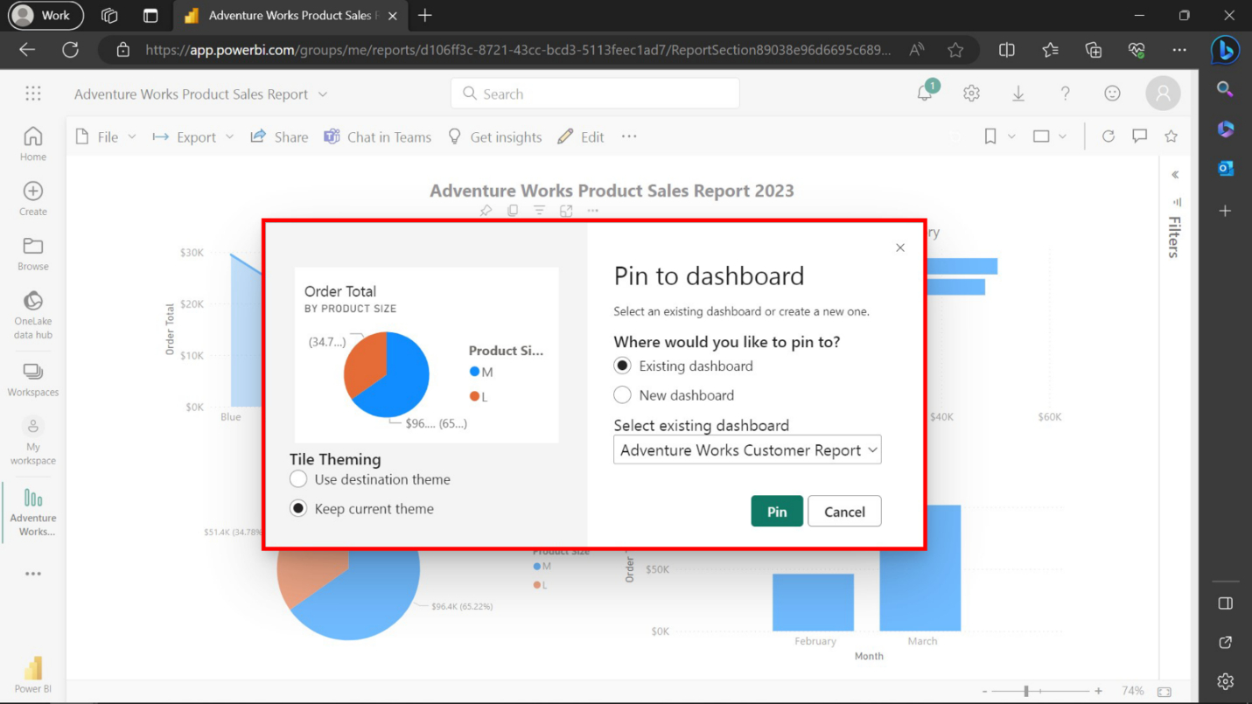

1. If you need to create a new dashboard for this visual, simply type the new dashboard name in the box.

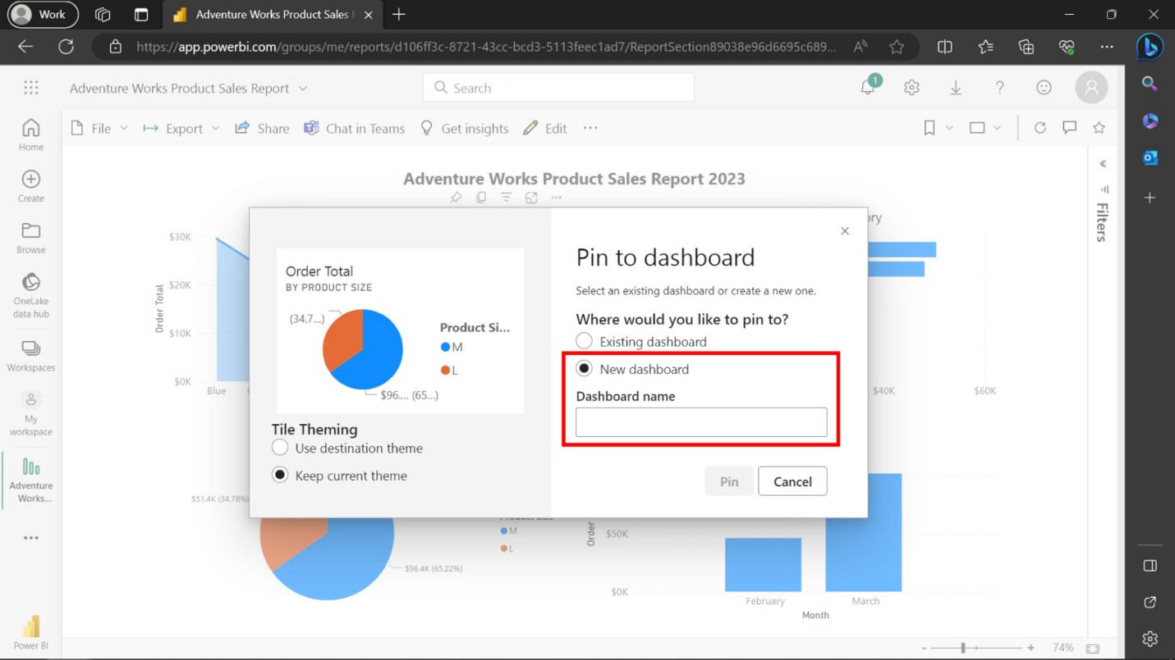

**Step 4: Confirm pinning**

Once you've selected the dashboard and added a title and subtitle, select **Pin**. This action will confirm your selection and pin the visual to your designated dashboard. As soon as you do this, a brief notification will pop up confirming that your visual has been successfully pinned.

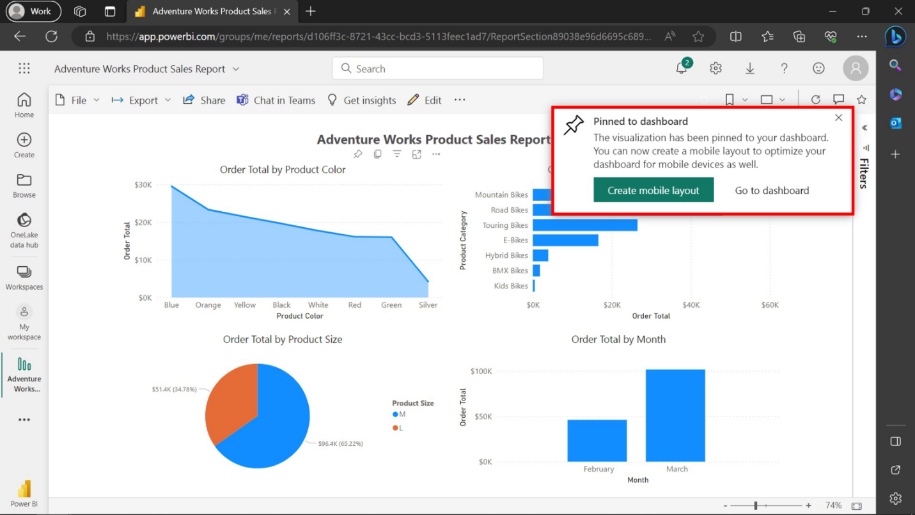

**Step 5: Visit the dashboard**

Now, navigate to the selected dashboard where you pinned your visual. Upon opening the dashboard, the newly added visual should now be represented as a tile. This tile can be moved around and resized according to your needs or preferences.

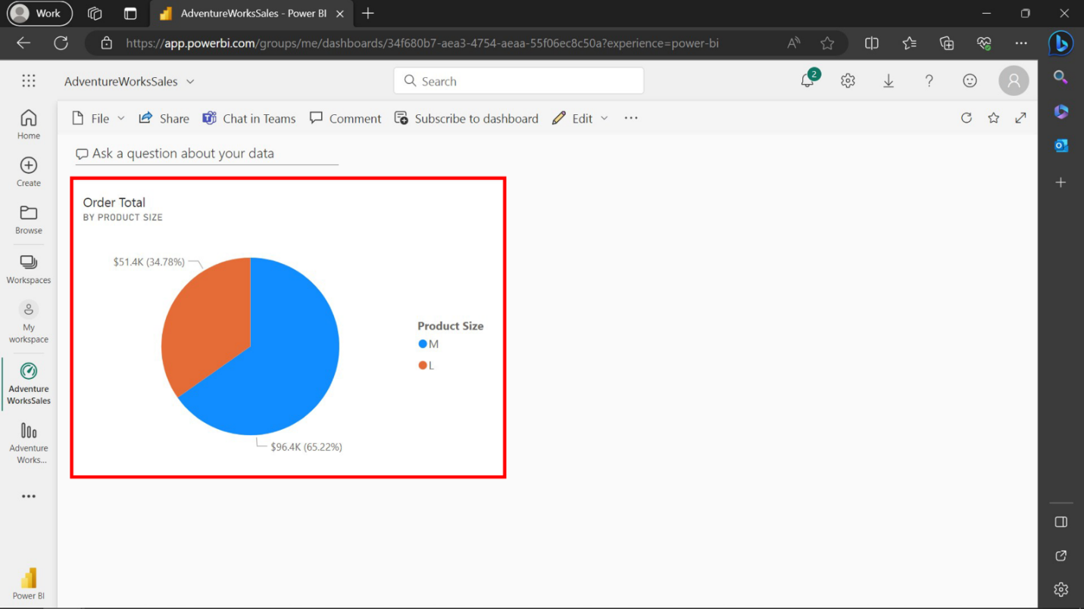

**Conclusion**

You have now mastered the process of pinning a visualization in Power BI. This newly acquired skill not only streamlines your workflow but also allows you to share critical data insights seamlessly. The power to customize, collaborate, and consistently access real-time data lies at your fingertips, enabling you to harness data's true potential. So, keep pinning, keep exploring, and remember—every pin is a stepping stone to a more data-driven decision.